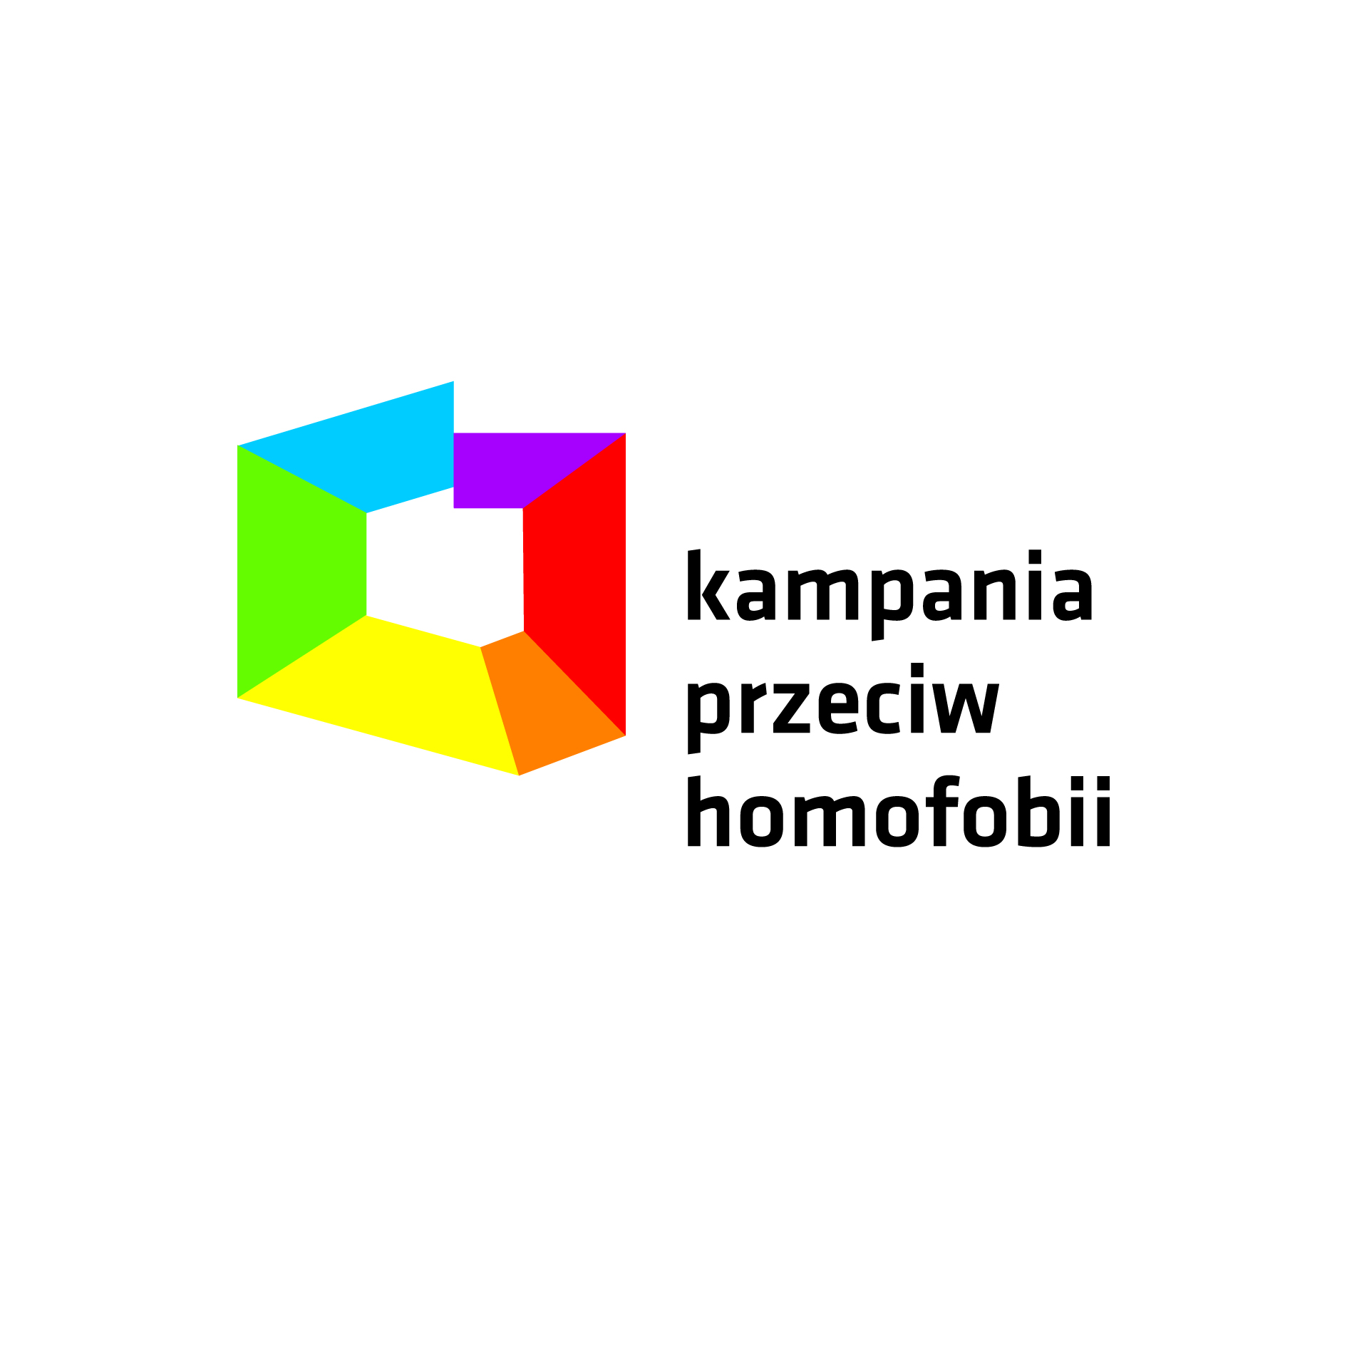

Title: National Identities: Processes of Identification Among Poland’s Jewish and LGBT Communities

Introduction
My name is Ian Bratcher and I am currently a third year PhD Candidate in the department of Sociology at the University of Michigan-Ann Arbor. I am writing to request your participation in an interview. My current research is focusing on both Jewish and LGBT groups in Poland, and how they identify with the nation, particularly in times of increasingly ardent nationalism.

Methods:
The primary methods for this research will be qualitative in nature. I endeavor to interview approximately 60 individuals, the broadest criteria being Polish citizens who identify as LGBT+ and/or Jewish, but I am also working to interview a mix of different generations (ages 18 +). Thus, while there is an age minimum for this research, there is no upper age limit. The interview would last roughly one hour, and can be conducted online. If you are not comfortable doing an interview online, but would be willing to meet in person, I will be in Poland this coming May and would be happy to schedule an interview. Given that this is a qualitative study, there are no formal hypotheses being tested.

Lastly, as you can see, I wrote this message in English as I am still working on my Polish (I am and have been taking Polish language courses here in Michigan and am planning to return to Warsaw in May) and am thus not yet at a level of proficiency that would let me hold a full interview in Polish. My hope is to be able to do so by this summer, but for now I am thinking that the interview would be in English. My apologies for any inconvenience.

Thank you for taking the time to read this letter and for considering my request. I look forward to hearing from you. If you have any questions, please do not hesitate to contact me (isbratch@umich.edu) or my dissertation director, Genevieve Zubrzycki (genez@umich.edu).

Pozdrawiam,
Ian Bratcher

